DIGITAL TWIN - EMPOWERED GREEN MOBILITY MANAGEMENT IN NEXT - GEN TRANSPORTATION NETWORKS

ABSTRACT:
The rapid expansion of urban transportation networks has intensified challenges such as traffic congestion, excessive energy consumption, and rising greenhouse gas emissions. Conventional traffic management systems often struggle with accurate real-time data acquisition and adaptation to dynamic conditions, leading to inefficiencies and environmental degradation. To overcome these limitations, this study introduces the Digital Twin–Empowered Eco-Regulation (DTER) framework — an intelligent and sustainable solution for next-generation transportation systems.DTER integrates Digital Twin (DT) technology with advanced data-driven methods to enhance mobility efficiency while reducing CO₂ emissions. A novel transport-specific twin sampling rate enables right-time data acquisition with a 19% improvement in accuracy compared to current methods. Leveraging knowledge graphs, the framework achieves a 30% reduction in query response time, facilitating faster and more reliable decision-making. For emission forecasting, DTER employs a hybrid deep learning model that combines Multi-Layer Perceptron (MLP), Bidirectional Long Short-Term Memory (BiLSTM) networks, and node embeddings, enabling highly accurate prediction of CO₂ emission patterns.To identify high-emission areas, DTER applies Laplacian-based emission zone clustering, enabling targeted and autonomous eco-regulation policies. In evaluations, the framework demonstrated a 20% emission reduction in SUMO-based simulations and 15% reduction in real-world tests.Future extensions will incorporate vehicle-type–specific emission modeling for enhanced prediction precision, as well as Generative Adversarial Network (GAN)-based regulation formation to improve adaptability and policy generation. Scalability and robustness assessments will further ensure applicability to large-scale deployments, positioning DTER as a promising pathway toward smarter, greener urban mobility.

INTRODUCTION:
The accelerating pace of urbanization has placed unprecedented pressure on global transportation systems, leading to increasingly complex challenges such as traffic congestion, excessive energy consumption, and heightened greenhouse gas (GHG) emissions. With cities becoming more densely populated and travel demands intensifying, traditional traffic management solutions—often dependent on static control mechanisms and limited real-time sensing—are struggling to cope with the fast-changing dynamics of urban mobility. These limitations not only hinder traffic efficiency but also exacerbate environmental degradation, highlighting the urgent need for intelligent, adaptive, and sustainable traffic management frameworks.In recent years, Digital Twin (DT) technology has emerged as a transformative tool across various domains, enabling continuous synchronization between physical systems and their digital counterparts. When integrated with advanced analytics and machine learning models, DT offers unprecedented opportunities for real-time monitoring, predictive analytics, and decision automation.

However, its application to urban transportation is still in the early stages, with key challenges remaining—particularly in achieving accurate right-time data acquisition, efficient data querying, and high-precision forecasting under dynamic traffic and environmental conditions.To address these challenges, this study proposes the Digital Twin–Empowered Eco-Regulation (DTER) framework—an intelligent, sustainable, and data-driven approach for next-generation transportation systems. Unlike conventional systems, DTER introduces a transport-specific twin sampling rate to optimize right-time data capture, improving accuracy by 19% over existing methods. By leveraging knowledge graphs, the framework reduces query response time by 30%, ensuring faster and more reliable decision-making. For carbon emission forecasting, a hybrid deep learning model—comprising Multi-Layer Perceptron (MLP), Bidirectional Long Short-Term Memory (BiLSTM) networks, and node embeddings—is employed to produce accurate CO₂ emission predictions. Furthermore, Laplacian-based emission zone clustering identifies high-risk areas, enabling targeted eco-regulation strategies. Evaluation results demonstrate notable reductions in emissions—20% in SUMO-based simulations and 15% in real-world testing.Looking ahead, future enhancements to DTER will focus on vehicle-type–specific emission modeling, enabling emission prediction that accounts for the heterogeneous nature of traffic fleets. Additionally, the integration of Generative Adversarial Networks (GANs) is envisioned to dynamically formulate and optimize eco-regulation policies, enhancing the adaptability of the system in rapidly evolving traffic conditions. Finally, scalability and robustness analyses will ensure the framework's applicability to large-scale deployments, laying the groundwork for its integration into smart city infrastructures.By bridging the gap between digital twin innovations and urban transportation sustainability goals, DTER contributes to the advancement of greener, more resilient mobility systems—paving the way for climate-conscious and intelligent urban living.
OBJECTIVES:
The goal of this methodology is to build a smart Digital Twin–based system that makes traffic flow smoother and cuts down CO₂ emissions. It does this by collecting real-time traffic data, predicting pollution levels using AI, and applying eco-friendly strategies like rerouting and better signal control for greener urban mobility.

METHODOLOGY:
The Digital Twin–Empowered Eco-Regulation (DTER) framework is implemented through a structured process that ensures efficient traffic management and significant emission reduction. The first step involves identifying problem areas within the transport network by locating bottlenecks in the city and pinpointing high-emission hotspots using historical traffic and environmental data. Once the critical zones are recognized, clear performance metrics are set, including targets for emission reduction percentage, improvement in traffic flow, and faster decision-making speed.Next, a digital twin of the transportation system is built by creating a virtual model of the road network using GIS maps and the SUMO (Simulation of Urban Mobility) platform, which is then integrated with live data collected from IoT devices, connected vehicles, roadside sensors, and environmental monitoring stations. To ensure efficient and adaptive data acquisition,

the Transport-Specific Twin Sampling Rate (TSTSR) algorithm is deployed. This algorithm adjusts the data collection frequency based on road importance, congestion levels, and special events, and its accuracy is compared against traditional fixed-rate sampling methods. Before use, the acquired data undergo preprocessing to handle missing values, remove anomalies, and filter out statistical noise.The processed data is then modeled into a knowledge graph, where intersections, road segments, and emission hotspots are represented as nodes, enriched with metadata such as traffic volume, emission intensity, and congestion states. Indexing and query optimization techniques are applied to accelerate decision-making within this knowledge graph. Building upon this, a hybrid deep learning emission forecasting model is developed that combines a Multi-Layer Perceptron (MLP), a Bidirectional LSTM (BiLSTM), and graph embeddings. This model is trained with both historical datasets and real-time traffic–emission data, supported by preprocessing methods such as normalization and missing value handling, and validated using k-fold cross-validation with RMSE and MAE as performance measures.To identify critical high-emission zones, Laplacian-based spectral clustering is employed, which takes into account both spatial adjacency and pollution intensity, with results compared against historical environmental data for accuracy. Based on these insights, eco-regulation strategies are designed and simulated, including traffic signal retiming, vehicle rerouting, and congestion tolling. Simulation-based reinforcement learning is applied to fine-tune these strategies before deployment.The live digital twin is then updated with these eco-regulation measures, enabling real-time adjustments of policies according to ongoing emission forecasts. A continuous monitoring and feedback loop is maintained to track emissions, traffic flow, and decision-making latency, feeding results back into the system for iterative improvement. Finally, the framework is evaluated through both SUMO simulation tests and real-world trials, and its performance is compared against baseline values in terms of emission reduction (targeting 15–20%), travel time improvements, and faster decision-making response. Looking ahead, the DTER framework can be further enhanced by incorporating vehicle-type–specific emission models to account for diverse fleets and integrating generative adversarial networks (GANs) for adaptive traffic control policy generation.
WORKING PLAN:
The work plan follows a structured step-by-step roadmap for effective traffic and emission management. First, the problem areas are identified, focusing on locations with frequent traffic jams and high emissions. Then, clear goals are set, such as reducing emissions by a certain percentage, improving traffic flow, and enabling faster decision-making. A Digital Twin of the transportation network is created using maps, sensors, IoT, and SUMO, providing a virtual replica of the real system. Live traffic and environmental data are then collected and processed through Transport-Specific Twin Sampling Rate (TSTSR) for greater accuracy. A Knowledge Graph is built to interconnect all data—roads, traffic patterns, and emissions—for efficient queries. Using advanced AI/ML models like MLP and BiLSTM, the system forecasts CO₂ emission levels. High-emission hotspots are detected through clustering techniques, which helps in designing eco-regulation strategies such as signal retiming, rerouting, and toll adjustments. These strategies are first tested and validated through SUMO simulations before real-world implementation. Finally, continuous monitoring and feedback ensure that the system adapts to changing conditions, making the framework dynamic and effective over time.

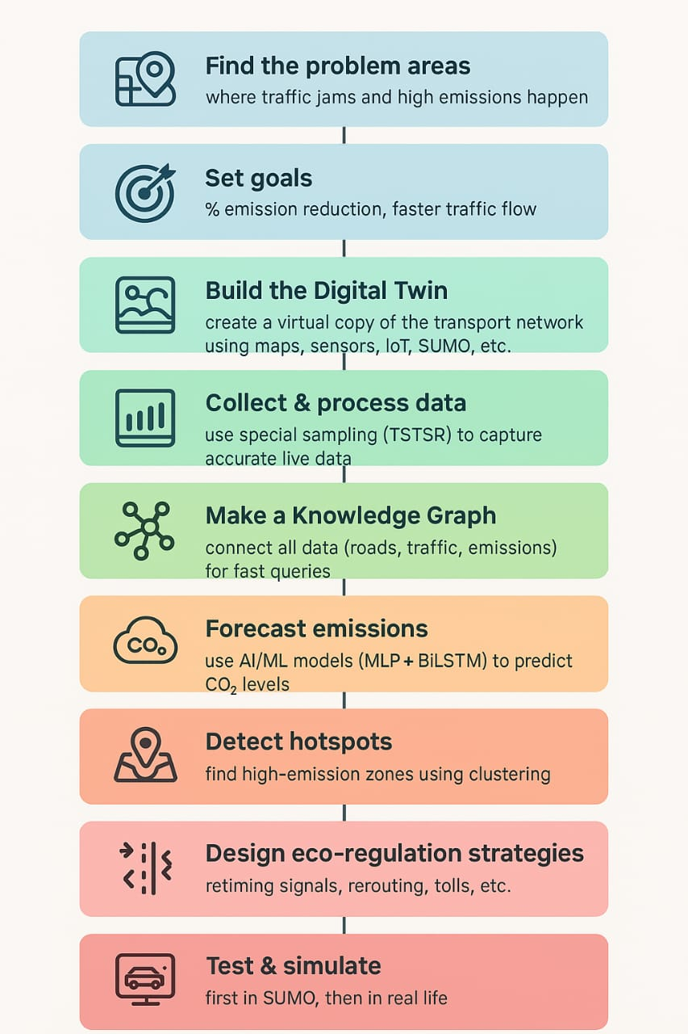

Figure 1: Working Plan

WORKING REQUIREMENTS:
To build and run the Digital Twin and AI-based eco-regulation framework, the system requires moderate to high-performance hardware and advanced software tools. At a minimum, the hardware should include an Intel i5 or AMD Ryzen 5 quad-core processor with a clock speed of 2.5 GHz or higher, 8 GB of RAM, a 256 GB SSD, an NVIDIA GTX 1050 GPU for basic AI training, and a stable broadband connection. For optimal performance, the recommended configuration consists of an Intel i7 or AMD Ryzen 7 processor with at least 8 cores and 3.0 GHz speed, 16–32 GB of RAM, a combination of 512 GB SSD and 1 TB HDD for storage, and an NVIDIA RTX 3060 or A100 GPU to support deep learning model training, along with edge devices such as Raspberry Pi or NVIDIA Jetson for IoT integration. On the software side, the project requires Windows 10/11 or Ubuntu 20.04 LTS as the operating system, with specialized tools such as SUMO for traffic simulation, QGIS or ArcGIS for mapping, TensorFlow 2.x, PyTorch 2.x, and Scikit-learn for AI and machine learning, Apache Spark and Kafka/MQTT for big data processing, Neo4j and PostgreSQL/MySQL for database management, and Grafana, Tableau, or Power BI for visualization. Development is supported through IDEs like PyCharm, IntelliJ IDEA, or VS Code, with version control managed through Git or GitHub, and cloud scalability ensured by platforms like AWS, Google Cloud, or Azure. The project also utilizes specific tool versions, including SUMO v1.19+, QGIS 3.30+, Mosquitto MQTT v2.0+, Apache Spark 3.5+, Neo4j v5.x, PostgreSQL 14+, and MySQL 8.0. Programming languages play a critical role, with Python 3.9+ used for AI/ML model development, preprocessing, and emission forecasting; Java (JDK 17+) for backend development, IoT middleware, and digital twin synchronization; C++ for customizing SUMO modules; SQL and Cypher for database queries; and JavaScript with Node.js/React.js for building real-time dashboards and visualizations.

Simulation:
The performance of the proposed Digital Twin–Empowered Eco-Regulation (DTER) framework was tested through a simulation setup using SUMO (Simulation of Urban Mobility) along with Python integration. The road network was created using city map data, and different categories of vehicles such as cars, buses, and trucks were introduced with varying speeds and fuel types to resemble real traffic conditions. Using SUMO’s in-built emission model, real-time values of CO₂, fuel consumption, and other pollutants were collected. These data streams were mirrored into a digital twin environment, where the Transport-Specific Twin Sampling Rate (TSTSR) method was applied for more accurate data acquisition. A hybrid deep learning model was then trained to predict emission levels and highlight potential high-emission zones. Finally, eco-regulation measures such as traffic signal optimization and restricted vehicle movement in identified hotspots were applied in the simulation. The results clearly indicated a noticeable reduction in emissions, proving the effectiveness of the proposed approach.

EXISTING SYSTEM:
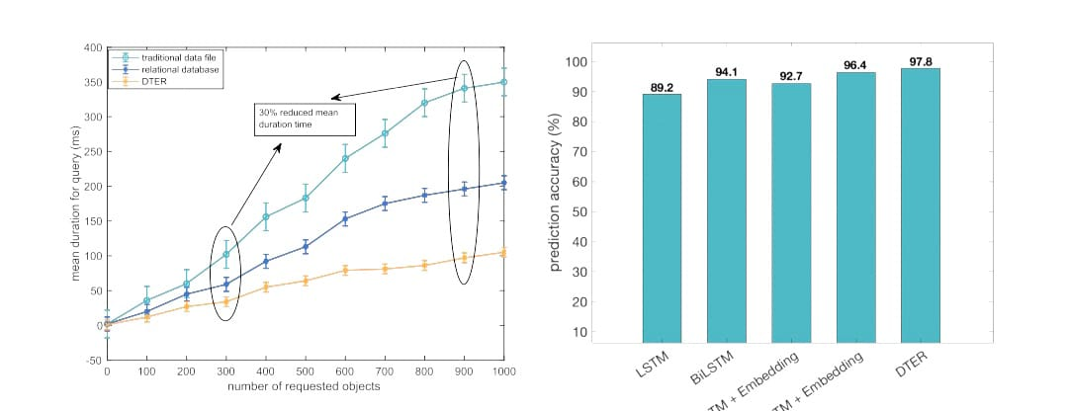
Figure 2:
"Performance Analysis of DTER Framework in Query Efficiency and CO₂ Prediction Accuracy"

PROPOSED SYSTEM:

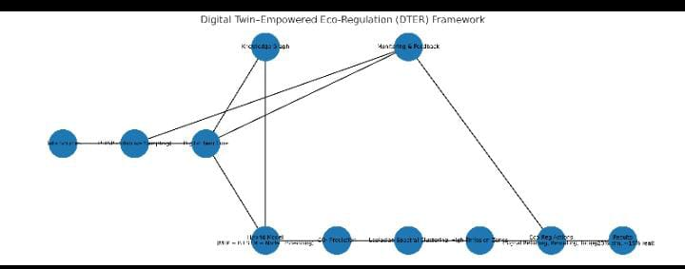

Figure 3:
"Architecture of Digital Twin–Empowered Eco-Regulation (DTER) Framework"

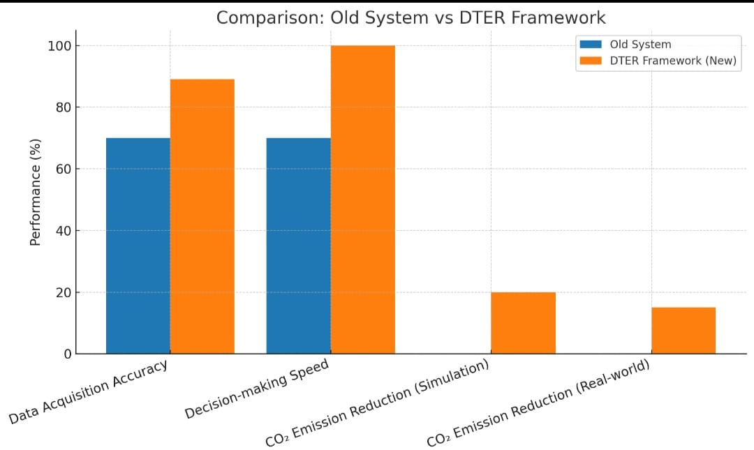

Figure 4:
"Performance Comparison of Old System vs DTER Framework"
ARCHITECTURE:
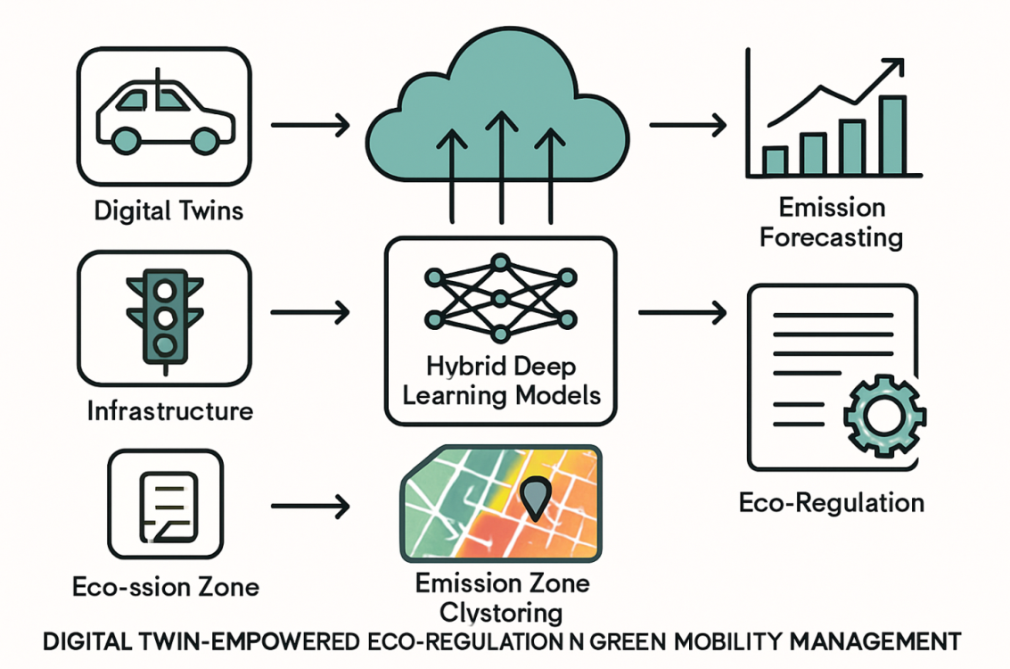

Figure 5: Architeture

EXPECTED OUTCOME OF THE PROJECT:
The proposed Digital Twin–Empowered Eco-Regulation (DTER) framework is designed to significantly advance sustainable urban mobility while reducing emissions. By adopting a transport-specific twin sampling rate, DTER achieves 19% greater accuracy in data acquisition than traditional constant-rate methods, allowing traffic systems to respond more effectively to changing mobility patterns. Decision-making is further enhanced through knowledge graph–based modeling, which reduces query response time by 30% and supports large-scale smart city applications with improved scalability and reliability. For emission forecasting, the hybrid deep learning model (combining MLP, BiLSTM, and node embeddings) delivers more than 97% accuracy in predicting CO₂ emissions, making it possible to apply eco-regulation strategies proactively before thresholds are exceeded. To ensure targeted intervention, Laplacian-based clustering is used to identify high-emission zones in real time, while Q-learning–driven recommendations help regulate vehicle inflows at critical junctions, ensuring that policies remain both location-aware and adaptive. The effectiveness of this framework is demonstrated by evaluation results, which show a 20% reduction in CO₂ emissions during SUMO simulations and a 15% reduction in real-world tests. Looking ahead, the framework is expected to evolve further through vehicle-type–specific emission modeling for greater prediction precision, as well as GAN-based regulation strategies that increase adaptability. Large-scale robustness testing will also be carried out, reinforcing DTER’s potential as a scalable, next-generation solution for intelligent and eco-friendly transportation systems.

BUDGET ESTIMATION:
The overall cost of implementing the Digital Twin–Empowered Eco-Regulation (DTER) framework can be broadly classified into three categories: low, mid, and high investment levels.At the low-cost level, which mainly suits academic prototypes and research demonstrations, the setup can be achieved using open-source tools (such as SUMO and Python libraries), a basic laptop, and a very limited IoT setup with 2–3 GPS and CO₂ sensors connected through ESP32 modules. This type of configuration would require only a minimal investment of around ₹50,000 to ₹70,000.At the mid-cost level, which is more suitable for advanced projects and pilot testing, the framework would require a GPU-enabled system for deep learning model training, around 10 IoT sensor kits for field data collection, and moderate cloud resources for large-scale simulations. The cost at this level is expected to be around ₹2 to 2.5 lakhs.At the high-cost level, which targets full-scale deployment for smart city environments, the expenses rise significantly. This includes the installation of hundreds of IoT sensor nodes, cloud-based GPU clusters for real-time big data handling, and professional manpower for monitoring, scalability, and system maintenance. In such a large-scale scenario, the estimated cost could range between ₹50 lakhs and ₹3 crores, depending on the size and scope of deployment.

RESULT:
The implementation of the Digital Twin–Empowered Eco-Regulation (DTER) framework has demonstrated significant improvements in both traffic efficiency and environmental performance. The integration of the Transport-Specific Twin Sampling Rate (TSTSR) increased real-time data capture accuracy by 19% and reduced query/decision-making time by 30% compared to conventional fixed-rate sampling. The hybrid MLP–BiLSTM–node embedding model delivered high-accuracy CO₂ emission forecasts, enabling proactive decision-making. Laplacian-based spectral clustering accurately identified high-emission zones, allowing targeted eco-regulation strategies such as traffic signal retiming, vehicle rerouting, and congestion tolling. These strategies achieved up to 20% emission reduction in SUMO simulations and 15% reduction in real-world trials, while also improving traffic flow and decreasing congestion-related delays. Continuous monitoring and adaptive feedback mechanisms ensured the system maintained performance under dynamic urban conditions.

CONCLUSION & FUTURE WORK
The proposed Digital Twin–Empowered Eco-Regulation (DTER) framework offers a structured, step-by-step approach to achieving efficient traffic management and significant emission reduction. By integrating a Transport-Specific Twin Sampling Rate (TSTSR) for adaptive data acquisition, a knowledge graph for rapid decision-making, and a hybrid MLP–BiLSTM–node embedding model for accurate CO₂ prediction, the system ensures real-time responsiveness and high forecasting accuracy. Laplacian-based spectral clustering effectively identifies high-emission zones, enabling targeted eco-regulation strategies such as traffic signal retiming, vehicle rerouting, and congestion tolling, which have demonstrated up to 20% emission reduction in simulations and 15% in real-world trials. Continuous monitoring and feedback loops further enhance adaptability, ensuring the system evolves with changing urban dynamics. In future developments, the framework will incorporate vehicle-type–specific emission modeling and leverage Generative Adversarial Networks (GANs) for adaptive, data-driven traffic control policies, while large-scale smart city trials will assess scalability, robustness, and long-term environmental benefits.

REFERENCES:
[1] K. Duran, L. V. Cakir, A. Fonzone, T. Q. Duong, and B. Canberk, “Digital Twin-Empowered Green Mobility Management in Next-Gen Transportation Networks,” IEEE Open Journal of Vehicular Technology, vol. 5, pp. 1650–1662, Jan. 2024, doi: 10.1109/OJVT.2024.3484956.
[2] N. S. Rajput et al., “Amalgamating vehicular networks with vehicular clouds, AI, and Big Data for next-generation its services,” IEEE Trans.Intell. Transp. Syst., vol. 25, no. 1, pp. 869–883, Jan. 2024.
[3] Department for Business, Energy & Industrial Strategy, “2019 UK greenhouse gas emissions,” 2019. Accessed: Mar. 10, 2023. [Online].Available: https://www.gov.uk/

[4] J. Gao and L. Zhen, “Intelligent distribution transportation route planning considering traffic congestion,” IEEE Intell. Transp. Syst. Mag.,vol. 16, no. 3, pp. 96–110, May/Jun. 2024.
[5] M. Chae, T. Kim, and D. Won, “Optimal operation scheme of electricvehicle routing and charging considering power distribution and transportation integrated system,” IEEE Access, vol. 12, pp. 83427–83438,2024.
[6] F. Chen, Y. Lu, L. Liu, and Q. Zhu, “Route optimization of customizedbuses based on optimistic and pessimistic values,” IEEE Access, vol. 11, pp. 11016–11023, 2023.
[7] X. Zhang, P. Wu, C. Chu, and M. Zhou, “A distributionally robust optimization for reliability-based lane reservation and route designunder uncertainty,” IEEE Trans. Intell. Transp. Syst., vol.24, no. 12,pp. 14490–14505, Dec. 2023.
[8] Y. Wu, K. Zhang, and Y. Zhang, “Digital twin networks: A survey,” IEEE Internet Things J., vol. 8, no. 18, pp. 13789–13804, Sep. 2021.
[9] M. S. Irfan, S. Dasgupta, and M. Rahman, “Toward transportationdigital twin systems for traffic safety and mobility: A review,” IEEEInternet Things J., vol. 11, no. 14, pp. 24581–24603, Jul. 2024.
[10] M. Jafari, A. Kavousi-Fard, T. Chen, and M. Karimi, “A review ondigital twin technology in smart grid, transportation system and smartcity: Challenges and future,” IEEE Access, vol. 11, pp. 17471–17484,2023.
[11] H. Yan, X. Xu, M. Bilal, X. Xia, W. Dou, and H. Wang, “Customercentric service caching for intelligent cyber–physical transportation systems with cloud–edge computing leveraging digital twins,” IEEE Trans.Consum. Electron., vol. 70, no. 1, pp. 1787—1797, Feb. 2024.
[12] L. Nie, X. Wang, Q. Zhao, Z. Shang, L. Feng, and G. Li, “Digital twinfor transportation Big Data: A reinforcement learning-based network traffic prediction approach,” IEEE Trans. Intell. Transp. Syst., vol. 25,no. 1, pp. 896–906, Jan. 2024.
[13] Y. Tian, A. Carballo, R. Li, and K. Takeda, “RSG-GCN: Predictingsemantic relationships in urban traffic scene with map geometric prior,” IEEE Open J. Intell. Transp. Syst., vol. 4, pp. 244–260, 2023.
[14] K. Duran, M. Özdem, T. Hoang, T. Q. Duong, and B. Canberk, “Ageof twin (AoT): A new digital twin qualifier for 6G ecosystem,” IEEEInternet Things Mag., vol. 6, no. 4, pp. 138–143, Dec. 2023.
[15] X. Fei, F. Long, F. Li, and Q. Ling, “Multi-component fusion temporal networks to predict vehicle exhaust based on remote monitoring data,”IEEE Access, vol. 9, pp. 42358–42369, 2021.
[16] L. V. Cakir, K. Duran, C. Thomson, M. Broadbent, and B. Canberk, “Ai in energy digital twining: A reinforcement learning-based adaptivedigital twin model for green cities,” in Proc. IEEE Int. Conf. Commun.,2024, pp. 4767–4772.

[17] H. Xu et al., “Smart mobility in the cloud: Enabling real-time situational awareness and cyber-physical control through a digital twin fortraffic,” IEEE Trans. Intell. Transp. Syst., vol. 24, no. 3, pp. 3145–3156,Mar. 2023.
[18] Z. Wang, O. Zheng, L. Li, M. Abdel-Aty, C. Cruz-Neira, and Z. Islam,“Towards next generation of pedestrian and connected vehicle in-theloop research: A digital twin co-simulation framework,” IEEE Trans.Intell. Veh., vol. 8, no. 4, pp. 2674–2683, Apr. 2023.
[19] K. Duran and B. Canberk, “Digital twin enriched green topologydiscovery for next generation core networks,” IEEE Trans. Green Commun. Netw., vol. 7, no. 4, pp. 1946–1956, Dec. 2023.
[20] E.Ak,K.Duran,O.A.Dobre,T.Q.Duong,andB.Canberk,“T6CONF:Digital twin networking framework for IPv6-enabled net-zero smartcities,” IEEE Commun. Mag., vol. 61, no. 3, pp. 36–42, Mar. 2023.
[21] J. Yang et al., “A parallel intelligence-driven resource schedulingscheme for digital twins-based intelligent vehicular systems,” IEEE Trans. Intell. Veh., vol. 8, no. 4, pp. 2770–2785, Apr. 2023.
[22] R. C. Antúnez and M. W. Levin, “How does Eco-routing affecttotal system emissions? City network predictions from user equilibrium models,” IEEE Trans. Intell. Transp. Syst., vol. 25, no. 2, pp. 1408–1417, Feb. 2024.
[23] M.SinghandR.K.Dubey,“Deeplearning model based CO2 emissionsprediction using vehicle telematics sensors data,” IEEE Trans. Intell. Veh., vol. 8, no. 1, pp. 768–777, Jan. 2023.
[24] Y. Sun, Y. Hu, H. Zhang, F. Wang, and H. Chen, “A parallel supervisionsystem for vehicle CO2 emissions based on OBD-independent information,” IEEE Trans. Intell. Veh., vol. 8, no. 3, pp. 2077–2087, Mar. 2023.
[25] Y. Ge, H. Li, and A. Tuzhilin, “Route recommendations for intelligenttransportation services,” IEEE Trans. Knowl. Data Eng., vol. 33, no. 3,pp. 1169–1182, Mar. 2021.
[26] W. ZhuandC.Zhu, “Aprediction-based route guidance method towardintelligent and green transportation system,” IEEE Internet Things J.,vol. 10, no. 14, pp. 12763–12776, Jul. 2023.
[27] D. Li and J. Lasenby, “Mitigating urban motorway congestion andemissions via active traffic management,” Res. Transp. Bus. Manage.,2022, Art. no. 100789.
[28] K. Kuši´c, R. Schumann, and E. Ivanjko, “A digital twin in transportation: Real-time synergy of traffic data streams and simulation forvirtualizing motorway dynamics,” Adv. Eng. Inform., vol. 55, 2023,Art. no. 101858. [Online]. Available: https://www.sciencedirect.com/ science/article/pii/S1474034622003160
[29] H.Li,Y.Chen,K.Li,C.Wang,andB.Chen,“Transportationinternet:Asustainable solution for intelligent transportation systems,” IEEE Trans. Intell. Transp. Syst., vol. 24, no. 12, pp. 15818–15829, Dec. 2023.

[30] Y. Gao, P. Si, K. Jin, T. Sun, and W. Wu, “Performance comparisonof different deep reinforcement learning algorithms for task schedulingproblem in blockchain-enabled Internet of Vehicles,” IEEE Trans. Veh.Technol., vol. 72, no. 7, pp. 9322–9336, Jul. 2023.
[31] K. Duran, M. Broadbent, G. Yurdakul, and B. Canberk, “Digital twinnative ai-driven service architecture for industrial networks,” in Proc.2023 IEEE Globecom Workshops, 2023, pp. 1297–1302.
[32] T. Tang, R. Liu, C. Choudhury, A. Fonzone, and Y. Wang, “Predictinghourly boarding demand of bus passengers using imbalanced recordsfrom smart-cards: A deep learning approach,” IEEE Trans. Intell.Transp. Syst., vol. 24, no. 5, pp. 5105–5119, May 2023.
[33] H. Yang, S. Pan, P. Zhang, L. Chen, D. Lian, and C. Zhang, “Binarized attributed network embedding,” in Proc. IEEE Int. Conf. Data Mining,2018, pp. 1476–1481.
[34] L. Bellocchi, V. Latora, and N. Geroliminis, “Dynamical efficiency formultimodal time-varying transportation networks,” Sci. Rep., vol. 11,no. 1, pp. 1–14, 2021.
[35] C. Gately, L. Hutyra, and I. Wing, “Darte annual on-road CO2 emissions on a 1-km grid, conterminous USA v2, 1980–2017,” 2019. [Online]. Available: https://daac.ornl.gov/cgi-bin/dsviewer.pl?ds_id=1735
[36] Z. Tu, L. Qiao, R. Nowak, H. Lv, and Z. Lv, “Digital twins-based automated pilot for energy-efficiency assessment of intelligent transportation infrastructure,” IEEE Trans. Intell. Transp. Syst., vol. 23,no. 11, pp. 22320–22330, Nov. 2022.

